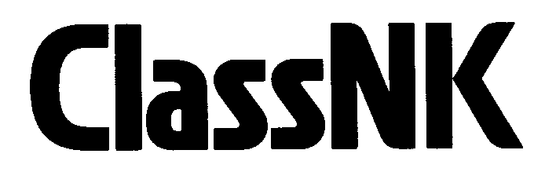
Application for the issuance of SOC on EU-SRR
(for Japanese Ship)

TO: NIPPON KAIJI KYOKAI
APPLICANT
Name  Address |  |  | Signature of Applicant
 |  |  | Name in Block Capitals
 | TEL |  | E-mail

We acknowledge the provisions of “REGULATIONS FOR TECHNICAL SERVICES” of NIPPON KAIJI KYOKAI (NK) and request the issuance of a statement of compliance (SOC) on Article 12 of the Regulation (EU) No. 1257/2013 on Ship Recycling (EU-SRR) for the following Japanese flagged vessel(s). We agree to pay all fees and expenses incurred as a result of the above-mention services regardless of whether the results of the services are acceptable or not.
SHIPS’ PARTICULARS
 | Name of ship | IMO No. | HBCCD usage*
1 |  |  | Yes / No
2 |  |  | Yes / No
3 |  |  | Yes / No
4 |  |  | Yes / No
5 |  |  | Yes / No
6 |  |  | Yes / No
7 |  |  | Yes / No
8 |  |  | Yes / No
9 |  |  | Yes / No
10 |  |  | Yes / No
* Usage of hexabromocyclododecane (HBCDD, a brominated flame retardant);
For applications after 31 December 2020, please indicate whether or not you have used HBCDD after 31 December 2020 or the date of IHM initial survey, whichever is later.

ATTACHMENT
- A copy of international certificate on inventory of hazardous materials (IHM certificate.) issued by JG.
(All applicable ships are required)

BILLING CONTACT (Note) Please complete the following only in cases where the billing contact and applicant are different.
Name  Address |  |  | Signature of Applicant
 |  |  | Name in Block Capitals
 | TEL |  | E-mail

Note:

